**CB[1] – Decomposition and Using Software**

Part I – Individual Quiz (Before Class)

Part II – Group Quiz (During Class)

1. What are the structural factors for a one-way CB design (2 pts)?

Factors = blocks, treatments.

1. How do you calculate the Estimated effect and degrees of freedom for the Blocks factor for a Complete Block Design (2 pts)?

Df = 1

DF = # blocks – 1

DF = # treatments – 1

DF= (# blocks – 1) * (# treatments -1)

Estimated effect = grand average +( B1 avg- GR avg) + (Tr avg – Gr avg) + (Obs – Fit)

**End of Part I**

1. Were you in class on time (2 pts)?

YES

1. Do decomposition of the data and an ANOVA table for the factors in the Auditor Training data (6 pts)

|  |  |  |  |  |  |
| --- | --- | --- | --- | --- | --- |
| **Anova Table** | | | | | |
|  | DF | SS | MS | F | P-Value |
| Grand Mean | 1 | 178332.3 | 178332.3 |  |  |
| Treatment | 2 | 1295.0 | 647.5 | 103.7537 | 1.32E-10 |
| Blocking | 9 | 433.3667 | 48.15185 | 7.715727 | 0.000132 |
| Residuals | 18 | 112.3333 | 6.240741 |  |  |

1. Get an ANOVA table using for the Auditor Training data and evaluate the results. Also, check the requirements of the residuals being normally distributed and that the variances are equal. (8 pts).
2. Analysis of Variance Table
3. Response: score
4. Df Sum Sq Mean Sq F value Pr(>F)
5. method 2 1295.00 647.50 103.7537 1.315e-10 ***
6. block 9 433.37 48.15 7.7157 0.0001316 ***
7. Residuals 18 112.33 6.24
8. ---
9. Signif. codes: 0 ‘***’ 0.001 ‘**’ 0.01 ‘*’ 0.05 ‘.’ 0.1 ‘ ’ 1

The F2,18 = 103.7537 and the p-value is very significant and this leaves us sufficient evidence to reject the null hypothesis that at least one mean is different.

Levene's Test for Homogeneity of Variance (center = median)

Df F value Pr(>F)

group 2 0.5241 0.598

27

We will accept the null with variance.

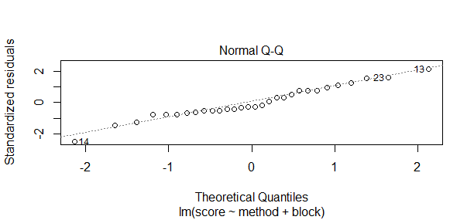

1. Do a basic factorial with just the method and without the block and compare results (3 points)
2. Analysis of Variance Table
3. Response: score
4. Df Sum Sq Mean Sq F value Pr(>F)
5. method 2 1295.0 647.50 32.037 7.441e-08 ***
6. Residuals 27 545.7 20.21
7. ---
8. Signif. codes: 0 ‘***’ 0.001 ‘**’ 0.01 ‘*’ 0.05 ‘.’ 0.1 ‘ ’ 1

The results aren’t much different still show us that we should reject the null and at least one mean is different.